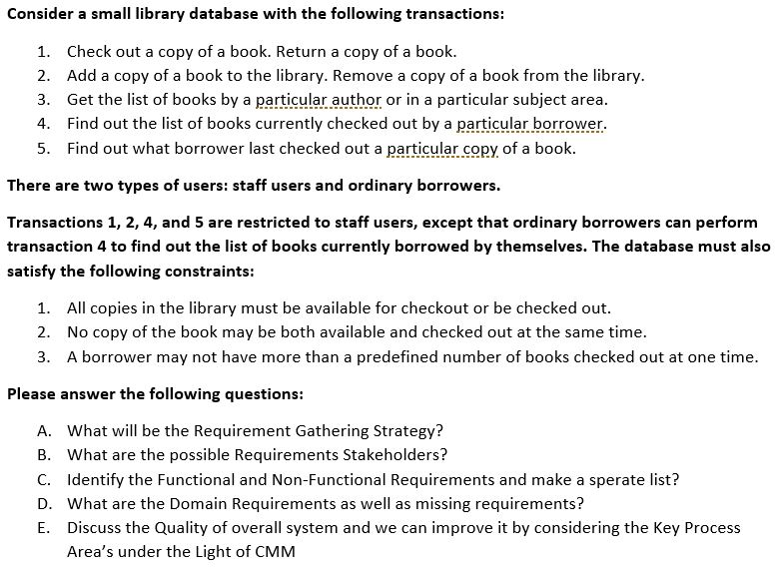Assignment # 4

1. What will be the Requirement Gathering Strategy?

We can take as many requirements as possible by brainstorming, interviews, and Surveys. because of these strategies we will be able to gather the requirements and verify the requirements at an early stage.

1. What are the possible Requirements Stakeholders?

* Staff Users.
* Ordinary borrowers.
* Database Developer.

1. Identify the functional and Non-Functional Requirements and make a separate list?

* **Functional Requirements**

1. Check Copy of books.
2. Return Copy of Books.
3. Add Copy of Books.
4. Remove Copy of Books
5. Search Copy of books
6. Currently checkout of books by borrower.
7. Last checked out book of borrower.

* **Non-Functional Requirements**

1. Restricted Transaction.
2. Security of database.
3. User Views.
4. Limited functionalities.
5. All copies must be available for check out.
6. Copy cannot be both available and checked out.
7. Borrower has limited numbers of checked out.
8. What are the Domain Requirements as well as missing requirements?

**Domain Requirements**:

1. Check Copy of books.
2. Return Copy of Books.
3. Add Copy of Books.
4. Remove Copy of Books
5. Search Copy of books
6. Currently checkout of books by borrower.
7. Last checked out book of borrower.

**Missing Requirements:**

1. Each member has 3 limits to have a book.
2. Notification sends on issue or return of book.
3. Each member can renew their identity card.
4. Collects fines for books return after due date.
5. User can reserve book if it is not available.
6. Discuss the quality of overall system and we can improve it by considering the Key Process Area under the light of CMM.

According to the system there are some requirements that are missing that can be fix by the system quality can be improve by, these KPA’s.

1. Project Planning: by this the missing requirements will be collected.
2. Peer Reviews: by this reviews system can verify.
3. Software Quality Management: by this overall quality of software can be analyze systematically.
4. Defect Prevention: It focuses on identification of causes of defects and to prevent them from recurring in future projects.